

National College of Ireland

**B.Sc. Honours in Computing, Year 3 (BSHC3A)**

**B.Sc. Honours in Computing (Evening), Year 3 (BSHC3E)**

**Semester 2 Examinations – May 2023**

______________________________________________________________________

**Software Applications for Business – Project Fact Sheet**

Sean Bonner

**Instructions:** This document should be completed as a team. Only ONE document should be submitted by the team overall. Each member of the team will be responsible for completing their aspects of the document and activity log.

**Note:** Replace the text in red with your paragraphs and data.

# Executive Summary

MCTV Limited is a small retail company based in Limerick that has been trading for over twenty years, with a turnover of €1 million per annum and a staff of five people. The company sells televisions, and it is owned by Michael and Doreen Cooney, who are in their 60s and have little grasp of the benefits of technology.

Derek, the eldest son, manages the Sales & Marketing function, Roberta, a recently qualified accountant, aspires to be the Financial Controller for the company. Mark and Liam, the other two sons, are both in their final year at the University of Limerick, pursuing Computer Science and Electronics degrees, respectively. John is employed as a shop assistant on a part-time basis.

The company currently uses MS Excel to record all business-related information, together with paper-based documents and reminder letters to customers of amounts owed. The family recently held a meeting to discuss how to spend up to €100,000 to improve the system. Derek suggested investing in a CRM system, Mark suggested enhancing the website to allow for online payments in a cloud-based environment, Roberta advocated moving to Sage, and Liam suggested investing in collaborative software facilitated by the cloud to avoid running each function in an isolated independent manner.

# Project Introduction

MCTV Limited is a small retail company based in Limerick, Ireland, which sells televisions. The company is family-owned and has a turnover of €1 million per annum with five employees. The owners, Michael, and Doreen are both in their 60s and lack an understanding of technology advancements, and they still use MS Excel and paper-based documents to manage their business. They have decided to invest €100,000 in improving their business operations and asked their family members, who are also their employees, to present proposals on how to spend the funds.

The eldest son, Derek, suggested investing in a customer relationship management (CRM) system to enhance customer relationships. Mark, who is pursuing a degree in computer science, suggested improving their website and enabling online payments through a cloud-based environment. Roberta, who works as a financial accountant, suggested moving from Excel to an integrated accounting package like Sage. Finally, Liam, who is pursuing a degree in electronics, suggested investing in collaborative software to break the silos of information and enhance teamwork.

# Scope

**The following items are not within the scope of the project:**

* Development of any mobile application
* Implementation of any advanced security features for the database or website
* Creation of any e-commerce functionality on the website
* Development of any custom software or programming
* Translation of the website into multiple languages
* Development of any social media or digital marketing strategies for the website or company
* Implementation of any third-party integrations with other software systems
* Conducting any market research or analysis for the company.

**The following items are within the scope of the project:**

* Completion of the template project fact sheet by all team members
* Updating the activity log by each team member
* Creation of a database for the company using provided and additional data
* Design of at least 4+ tables, 2 queries/SQL statements, 4+ reports and forms for the database
* Development of a navigational database that is easy to get around.
* Inclusion of a suggestion form for staff members to provide feedback on how to improve the business.
* Design of a colour scheme for the company using the three-colour rule
* Creation of a Use Case Diagram for the database demonstrating how data flows
* Use GitHub to share documents and creation of a report at the end.
* Use of Trello as a project management tool to track progress and update tasks.
* Development of a WordPress website for the project
* Inclusion of a Home page and About Us page on the website, detailing what the project is and what was required, and information about each team member's contributions respectively.
* Hosting of the website so it is accessible via a web address.

# Project Links

|  |  |
| --- | --- |
| Description | Link (URL) |
| Trello board | <https://trello.com/invite/b/GmKKCAUe/ATTIe3a18416800d6d460aef313d6c7e2aefC4FE8927/trello-board> |
| WordPress | <https://wp.me/PeIO7l-5> |
|  |  |
|  |  |
|  |  |

# Roles and Responsibilities

|  |  |  |  |
| --- | --- | --- | --- |
| Name | ID (student #) | Role | Responsible for: |
| CHIDIMMA NLIAM | 22480626 | Derek |  |
| SHAMAN ELOBO | 22479056 | Mark |  |
| SAFA SALEEM  VIOLA SOMOGYI | 22719021  22458052 | Roberta  Liam |  |

# Activity Log

## Week 1

|  |  |  |  |
| --- | --- | --- | --- |
| Team member | What did you complete this week | What was completed last week | Were there any issues/challenges found? |
| Shaman | Microsoft Database |  |  |
| Chidimma | Microsoft Database |  | Difficult but with information from moodle it was easier. |
| Viola | UML |  | It was my first time doing a UML chart but it was easier than I thought. |
| Safa | UML |  |  |
|  |  |  |  |

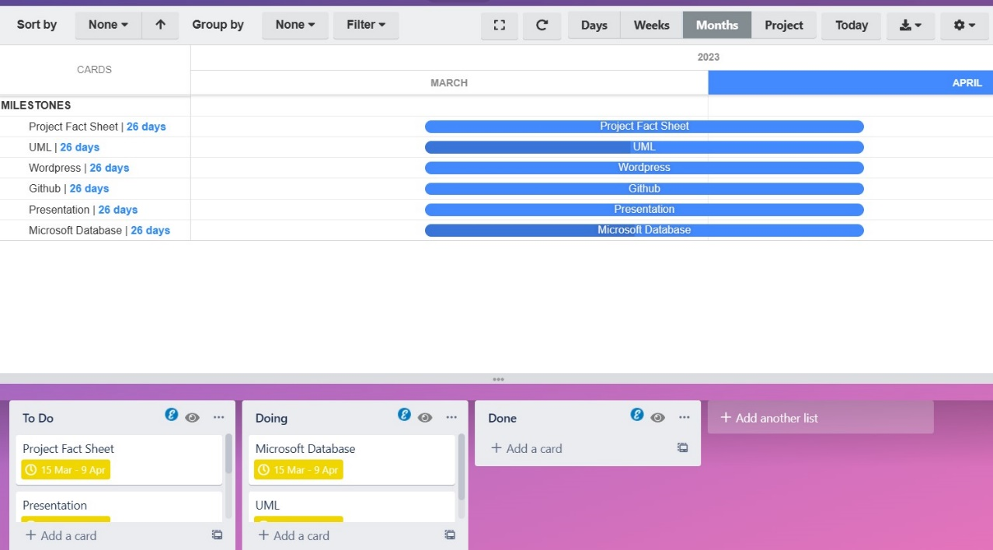

## Week 2

|  |  |  |  |
| --- | --- | --- | --- |
| Team member | What did you complete this week? | What was completed last week? | Were there any issues/challenges found? |
| Shaman | Executive summary & SCOPE | Microsoft Database | It was my first-time summarising quite a large amount of information. |
| Chidimma | Project Introduction | Microsoft Database |  |
| Viola | project introduction | UML |  |
| Safa | SCOPE | UML | Pretty straight forward, but had to search how to do it first. |
|  |  |  |  |

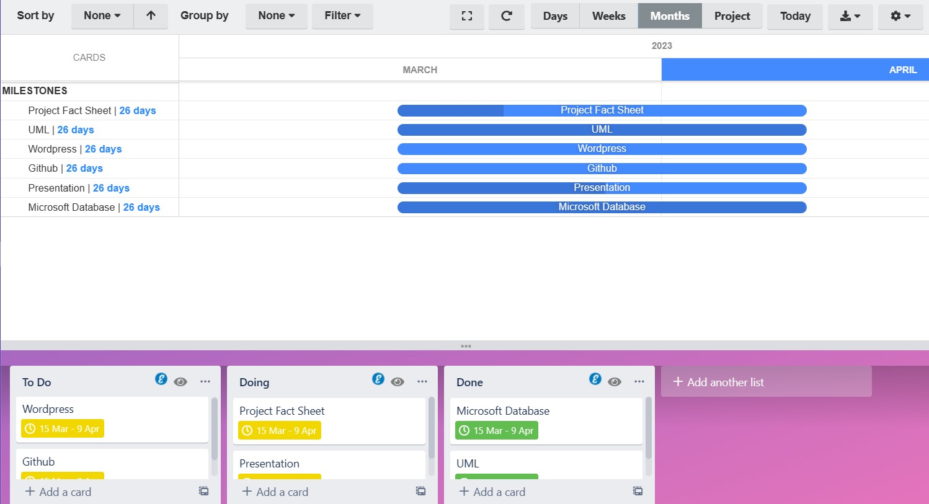

## Week 3

|  |  |  |  |
| --- | --- | --- | --- |
| Team member | What did you complete this week | What was completed last week | Were there any issues/challenges found? |
| Shaman | Presentation | Executive Summary & Scope |  |
| Chidimma | presentation | Project Introduction |  |
| Viola | presentation | Project Introduction |  |
| Safa | presentation | Scope |  |
|  |  |  |  |

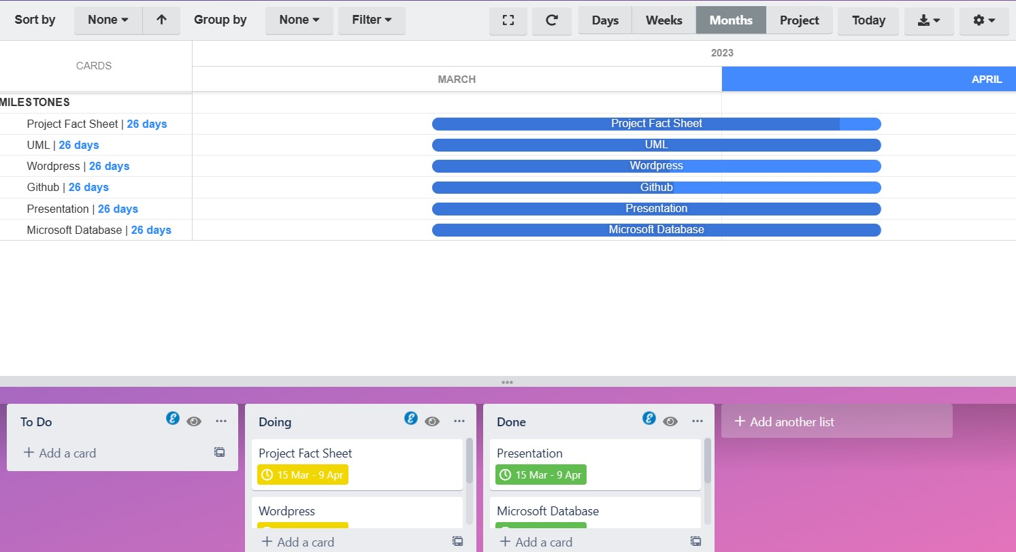

## Week 4

|  |  |  |  |
| --- | --- | --- | --- |
| Team member | What did you complete this week | What was completed last week | Were there any issues/challenges found? |
| Shaman | WordPress | presentation |  |
| Chidimma | GitHub | presentation |  |
| Viola | WordPress | Presentation | We all found using WordPress difficult but got easier working together. |
| Safa | GitHub | presentation |  |
|  |  |  |  |

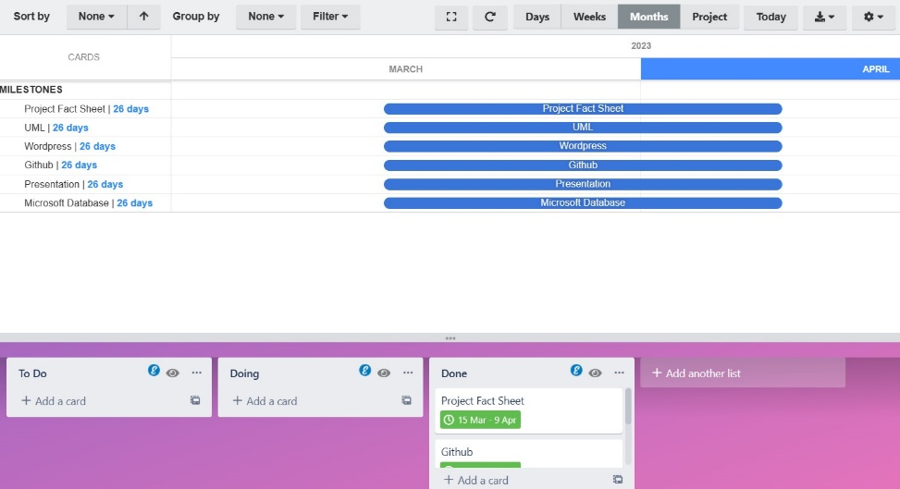

# Project conclusion

The overall project was very difficult the Microsoft database wasn’t easy to complete as we had to add at least 4 more tables to the information that was already there. But with teamwork, we’re able to concentrate and complete the Microsoft database for MCTV LTD.

The WordPress website was difficult to get started but once we understood from watching videos available on Moodle, we quickly understood what to do. It was difficult to make a template for the UML chart from scratch but with the help of diagram.io, we were able to complete the UML chart successfully.

The presentation was the easiest thing to finish as we had all the information completed to gather & finish the assignment.

Overall, we are glad to have experienced a complex but hard group assignment it was rewarding to work together on such a complex assignment.